Introduction To Microsoft Azure Notes
💻 Before Cloud Computing (Old Method)
In the past, companies had to:
- Buy Computers (Servers) 🖥️
  - Companies bought big special computers called servers to store data and run websites or software.
- Keep Servers in a Room (Data Center) 🏢
  - These servers were kept in a special room with cooling, electricity, and security.
  - This room is called a data center.
- Pay a Lot of Money 💸
  - Buying servers, power, cooling, and IT staff cost a lot of money.
  - It also took time to set up.
- Problem if Business Grows 📈
  - If more customers come, the company needs more servers — takes time and more money.

🤔 So, What Was the Problem?
Problem | Why it's a problem
High Cost | Buying and maintaining servers is expensive
Time-Consuming | Setup takes days or weeks
Not Flexible | Hard to add or remove resources quickly
Needs Experts | Companies need IT people to manage everything

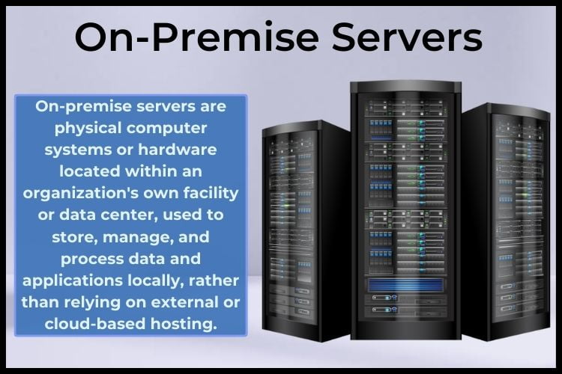

Then Came Cloud Computing
Earlier, companies had to buy big computers (called servers) and keep them in a special room.
This cost a lot of money, time, and effort.
So, a new idea came – it is called Cloud Computing.

What is Cloud Computing?
- Cloud computing means using computers and storage through the internet.
- You don’t have to buy big computers.
- You can use Microsoft’s or Google’s computers through the internet.
- It is like using electricity — you just pay for what you use.
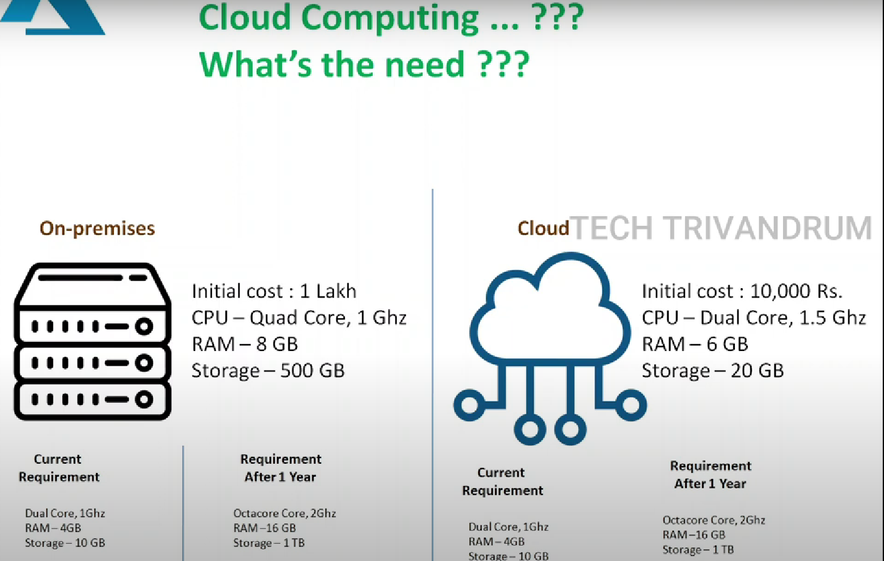

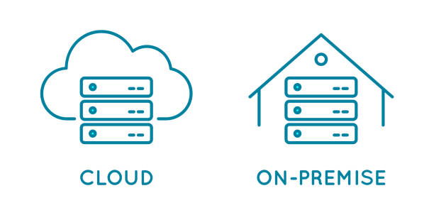

📱💻 Examples You Already Use:
You are already using cloud computing when you:
- Save files in Google Drive or OneDrive
- Watch videos on YouTube
- Use Gmail or WhatsApp Web
These apps use cloud servers — you don’t need to install them on your own computer.

✅ Top Benefits of Cloud Computing
- Cost 💰
➤ You don't need to buy expensive computers — just pay for what you use.
- Scalability 📈
➤ You can easily increase or decrease resources as your needs change.
- Performance ⚡
➤ Cloud servers work fast and are updated regularly for better speed.
- Security 🔒
➤ Your data is protected with strong security by experts.
- Productivity 👨‍💻
➤ IT teams can focus on work instead of maintaining hardware.
- Speed & Flexibility 🚀
➤ You can start and adjust services quickly from anywhere.
- Reliability ✅
➤ Cloud services work all the time with backup and recovery support.

What is Microsoft Azure?
- Microsoft Azure is Microsoft’s cloud platform.
- It gives you tools to:
✅ Store data
✅ Run websites and apps
✅ Use databases
✅ Use Artificial Intelligence (AI)
✅ And more…
All this happens online – no need to buy or install anything.

🛠️ What Can People Do With Azure?
Azure Tool | What it Does
Virtual Machines | Like a computer on the internet
App Services | Host websites and apps
Storage | Save photos, videos, and files
SQL Database | Save and manage data like names, marks
AI Tools | Make smart apps like chatbots

🎁 Why People Use Azure?
- 💰 Cheaper – No need to buy expensive machines
- 🚀 Fast – You can start in a few minutes
- 🧑‍💻 Easy – No need to manage big computers
- 🌍 Available Anywhere – Use it from any place with internet
- 🔐 Safe – Microsoft protects your data

☁ Types of Cloud in Cloud Computing
There are three main types of cloud:

1️⃣ Public Cloud
- Provided by companies like Microsoft (Azure), Google (GCP), Amazon (AWS).
- Anyone can use it — shared by many users.
- You only pay for what you use.
Example: Using Google Drive or Microsoft Azure.
🟢 Easy to use and low cost.

2️⃣ Private Cloud
- Used by one company only — not shared with others.
- More secure and private.
- Can be hosted in the company’s own data center or by a provider.
Example: A bank using its own cloud for customer data.
🔒 More control and security.

3️⃣ Hybrid Cloud
- A mix of public and private cloud.
- Companies use private cloud for sensitive data and public cloud for regular work.
Example: Hospital stores patient data in private cloud but uses public cloud for appointments.
🔁 Best of both worlds – flexible and secure.

📌 Summary Table
Type | Used By | Shared? | Example Use
Public Cloud | Anyone | Yes | Email, file storage
Private Cloud | One company only | No | Bank or government
Hybrid Cloud | Big organizations | Mix | Hospitals, businesses

☁️ Types of Cloud Service Models
(Also called Cloud Service Layers)
There are 3 main types of cloud service models:

1️⃣ IaaS – Infrastructure as a Service
- Gives you basic building blocks like virtual machines, storage, and networks.
- You get a computer on the internet and control what you install on it.
- You manage the software, and the provider manages the hardware.
Example: Microsoft Azure VM, Amazon EC2
🛠 Like renting a computer to install your own apps.

2️⃣ PaaS – Platform as a Service
- Gives you a ready platform to build and run apps.
- You don’t worry about the operating system or server.
- Just write your code — the provider manages everything else.
Example: Azure App Service, Google App Engine
👨‍💻 Like using a kitchen with all tools ready — just cook!

3️⃣ SaaS – Software as a Service
- Gives you ready-to-use software through the internet.
- You don’t install anything — just open and use it.
- Everything is managed by the provider.
Example: Gmail, Microsoft 365, Google Docs
📧 Like using Gmail — open your browser and use it!

📌 Summary Table
Model | What You Get | What You Manage | Example
IaaS | Virtual Machine | Your apps and OS | Azure VM, AWS EC2
PaaS | Platform to build apps | Just your code | Azure App Service
SaaS | Ready software | Nothing – just use it | Gmail, MS 365

